SOFTWARE REQUIREMENTS SPECIFICATION
Hostel Management System

Version 1.0
Prepared by: Amarnath,Subham
Institution: GIET University, Gunupur
Date: August 2026

Table of Content

1. Introduction

1.1 Purpose
This Software Requirements Specification (SRS) defines the functional and non-functional requirements for the Hostel Management System (HMS). The purpose of the system is to automate hostel room allocation, fee tracking, complaint/maintenance management, and visitor logging, replacing the manual, paper-register-based process currently used by hostel administration.

1.2 Document Conventions
Functional requirements are labelled FR1, FR2, etc. Non-functional requirements are labelled NFR1, NFR2, etc. The keywords "shall" and "must" indicate mandatory requirements.

1.3 Intended Audience and Reading Suggestions
This document is intended for the hostel warden and superintendent, university administration, the development team, quality assurance staff, and project evaluators. Sections 1-2 provide background and scope; Sections 3-5 provide detailed requirements; Sections 6-8 provide the system's design models.

1.4 Product Scope
Purpose: To define the requirements for a system that automates hostel room allocation, fee tracking, complaint management, and visitor logging.
Scope: Covers room allocation, fee payment tracking, complaint/maintenance requests, and visitor logs. Excludes mess/catering management.
The system aims to give students real-time visibility into room status, fees, and complaint status; reduce manual paperwork and allocation errors; and generate occupancy and revenue reports for hostel administration.

1.5 References
- IEEE Std 830-1998, Recommended Practice for Software Requirements Specifications
- Internship Workbook: "Writing SRS for Better Data Analytics" — Hostel Management System project workbook

2. Overall Description

2.1 Problem Statement
Hostel processes such as room allocation, fee collection, complaint handling, and visitor tracking are currently managed through paper registers, causing delays, double allocations, missed fee dues, and slow complaint resolution.
Why does this problem exist? There is no centralized system linking room availability, student fee status, and maintenance requests, so wardens rely on manual registers that are error-prone and don't scale as hostel occupancy grows.

2.2 Product Perspective
The Hostel Management System is a new, self-contained web-based application. It integrates with two existing external systems: the university's student ID database and the hostel's fee payment gateway. It is not a replacement for the university's core ERP but a focused subsystem for hostel operations.

2.3 Product Functions
- Automate room allocation and vacancy tracking
- Digitize fee payment and due tracking, with penalty rules
- Enable online complaint/maintenance request submission and tracking
- Maintain visitor entry/exit logs for security compliance
- Generate occupancy and revenue reports for admin
- Provide automated notifications for fee due dates and complaint status updates
- Support renewal/checkout workflows each academic year

2.4 User Classes and Characteristics
User class | Description | Digital literacy
Students (residents) | Submit complaints, view room and fee status, pay fees | Basic
Warden / Superintendent | Allocate rooms, approve/assign complaints, oversee operations | Basic
Accounts / Admin office | Track fee payments and dues, generate reports | Familiar with spreadsheet/ERP tools
Maintenance staff | Receive and resolve assigned complaints | Basic
Parents / guardians | View-only access to fee status | Basic

2.5 Operating Environment
The system is a web-based application accessible via standard browsers on desktop and mobile devices, hosted on institution-approved infrastructure, and integrated with the existing student ID database and hostel fee payment gateway via APIs.

2.6 Design and Implementation Constraints
Constraints: The system must integrate with the existing hostel fee payment gateway and student ID database.

2.7 Assumptions and Dependencies
Assumptions: All students have valid registration IDs; wardens have access to internet-enabled devices.

3. Stakeholders

3.1 Internal Users
Hostel warden, superintendent, accounts/admin office, maintenance staff.

3.2 External Users
Parents/guardians, university administration, local security/visitor compliance.

3.3 Expected System Users
Students (residents), wardens, admin staff, maintenance staff, and parents (view-only access).

4. Specific Requirements — Functional
The functional requirements below define the mandatory system behaviours. Each is mapped to the module that implements it.

4.1 FR1 — Room Allocation
Requirement: The system shall allow admin to allocate and reassign hostel rooms based on availability.
Actor(s): Admin / Warden
Rationale: Automates the currently manual, error-prone process of assigning rooms, preventing double allocation.

4.2 FR2 — Fee Payment Tracking
Requirement: The system shall track fee payments and automatically flag overdue dues.
Actor(s): Student, Accounts/Admin
Rationale: Digitizes fee due tracking and reduces missed payments through automated flags and reminders.

4.3 FR3 — Complaint Management
Requirement: The system shall allow students to submit and track maintenance complaints online.
Actor(s): Student, Warden/Admin, Maintenance staff
Rationale: Provides real-time complaint status and reduces repeated office visits.

4.4 FR4 — Visitor Logging
Requirement: The system shall log visitor entry and exit details with timestamp and purpose.
Actor(s): Security staff / Warden
Rationale: Maintains a digital, auditable visitor record for security compliance.

4.5 Functional Requirements Summary
ID | Requirement | Priority
FR1 | Allow admin to allocate and reassign hostel rooms based on availability | High
FR2 | Track fee payments and automatically flag overdue dues | High
FR3 | Allow students to submit and track maintenance complaints online | High
FR4 | Log visitor entry and exit details with timestamp and purpose | Medium

5. Specific Requirements — Non-Functional

5.1 NFR1 — Availability
Requirement: The system shall be available 99% of the time, including during peak admission/allocation periods.

5.2 NFR2 — Performance and Scalability
Requirement: The system shall support at least 500 concurrent users without performance degradation, with page load times under 2 seconds.

5.3 NFR3 — Security
Requirement: The system shall encrypt student personal and payment data in compliance with data protection norms.

5.4 Non-Functional Requirements Summary
ID | Category | Requirement
NFR1 | Availability | 99% uptime, including peak admission/allocation periods
NFR2 | Performance | 500+ concurrent users; page loads under 2 seconds
NFR3 | Security | Encryption of personal and payment data in compliance with data protection norms

6. External Interface Requirements

6.1 User Interfaces
Web-based portal with role-based dashboards for students, wardens/admin, maintenance staff, and a view-only portal for parents. Key screens: login, dashboard, room allocation, fee status, complaint submission/tracking, visitor log.

6.2 Hardware Interfaces
Standard desktop, laptop, or mobile devices with a modern web browser and internet connectivity. Optional QR/ID scanning hardware for digital visitor entry logging.

6.3 Software Interfaces
- Hostel fee payment gateway — for processing and reconciling student fee payments
- Student ID database (university system) — for validating student identity and enrollment status

6.4 Communication Interfaces
HTTPS for all client-server communication; automated email/SMS notifications for fee due dates and complaint status updates.

7. Use Case Model
The table below lists the primary use cases identified for the system, along with their actors and objectives.
Use case | Actor | Objective
Allocate room | Admin / Warden | Assign a vacant room to a student
Submit complaint | Student | Report a maintenance issue
Track fee payment | Student / Accounts | View and update fee payment status
Log visitor entry | Security staff | Record visitor details for security compliance
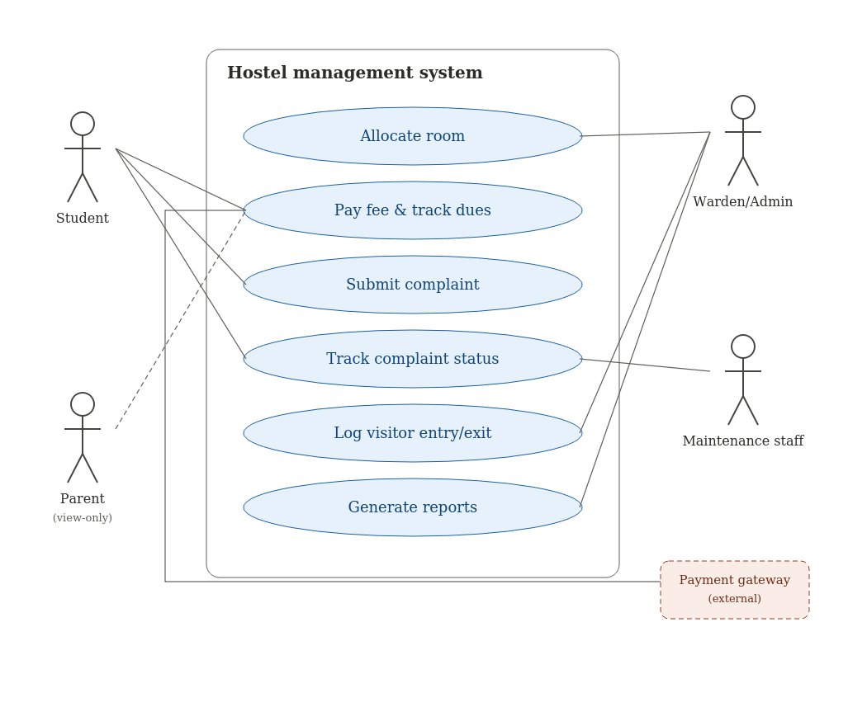
Figure 7.1 — Use case diagram for the Hostel Management System

8. System Design Models (UML)

8.1 Sequence Diagram
The sequence diagram below shows the interaction flow when a student submits a room request or complaint: the request is routed through the portal to the Warden/Admin, who approves or assigns it; the system then updates the database and notifies the student.
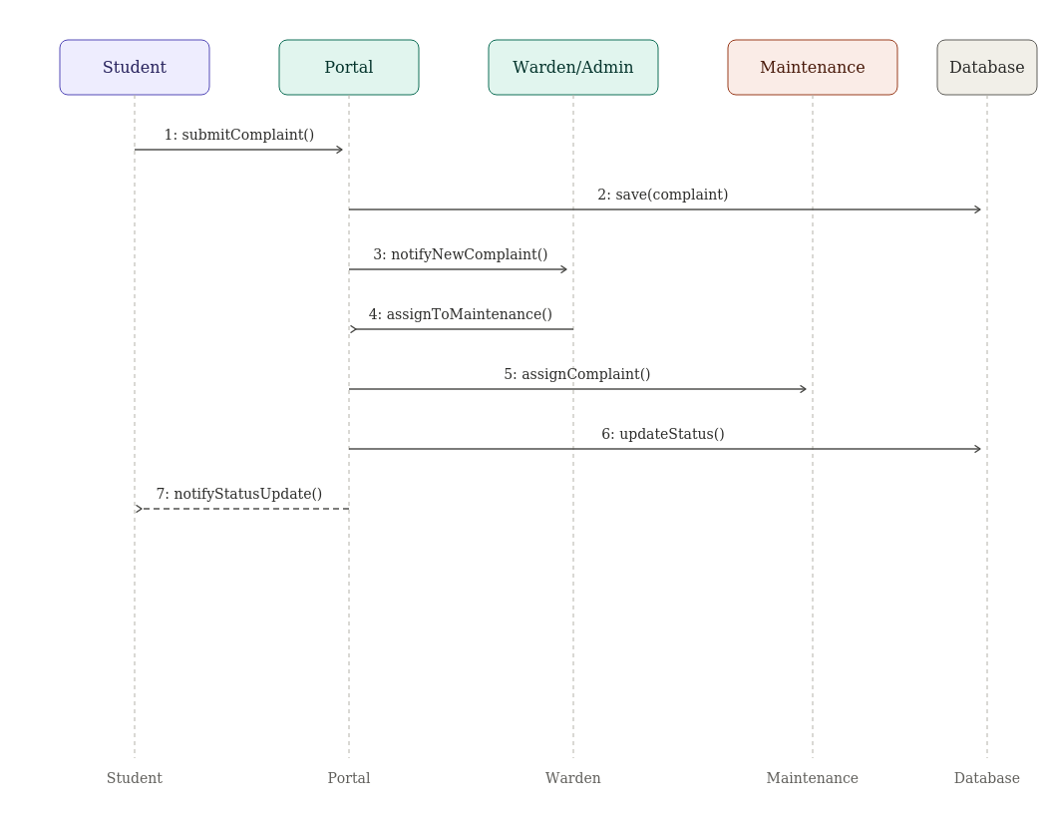
Figure 8.1 — Sequence diagram for complaint submission and routing

8.2 Collaboration Diagram
The collaboration diagram represents the same interaction spatially, showing the objects involved and the numbered message flow: Request → Route → Approve/Assign → Update → Notify.
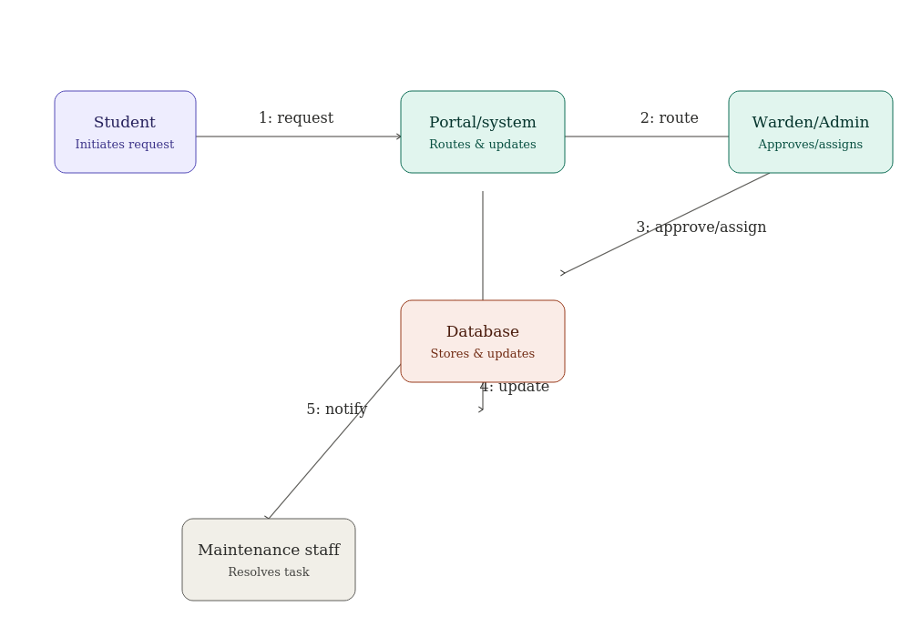
Figure 8.2 — Collaboration diagram for complaint and room request handling

9. Database Design

9.1 Entities and Attributes
Entity | Attributes
Student | StudentID (PK), Name, Email
Course | CourseID (PK), CourseName
Room | RoomID (PK), BlockName, FloorNumber, Capacity, Status
FeePayment | PaymentID (PK), StudentID (FK), Amount, DueDate, Status

9.2 Keys and Relationships
- Primary keys: StudentID (Student), RoomID (Room), PaymentID (FeePayment)
- Foreign key: StudentID in the Room and FeePayment tables references the Student table
- Relationship: one Student is allocated one Room; one Student has many FeePayment records (one-to-many)

10. Feasibility Analysis

10.1 Technical Feasibility
Yes. Room-allocation, fee-tracking, and complaint web apps — along with payment gateway integration — use mature, low-cost technologies that integrate easily with existing student databases via APIs.

10.2 Economic Feasibility
Estimated cost: moderate, mainly web hosting and payment-gateway integration fees. Benefits: reduced fee defaults, faster complaint resolution, and less administrative staff time. Cost is expected to be recovered within 1-2 years.

10.3 Operational Feasibility
Yes — wardens and admin already perform these tasks manually, so the system reduces effort rather than adding new work; brief training is enough for adoption.

10.4 Schedule Feasibility
Yes — a working prototype (room allocation + fee tracking + complaint module) can be built and piloted within one semester using an agile approach.

11. Ethical, Regulatory, and Privacy Considerations

11.1 User Ethics
Students must be informed about what personal and payment data is collected and how it is used.

11.2 Business Ethics
Fee and complaint data must not be used for purposes beyond hostel administration.

11.3 Regulatory Ethics (Domain-Specific)
The system must comply with institutional data protection policy and any local visitor/security regulations.

11.4 Data and Privacy
Payment and ID data must be stored encrypted and access-restricted to authorized admin roles only.

11.5 AI and Technology-Related
If predictive fee-risk or maintenance scoring is used, results should be reviewable by staff rather than fully automated decisions.

11.6 Development Ethics
The development team must test the system to ensure no student group (e.g., by room block) is unfairly flagged or deprioritized.

12. Appendix

12.1 Glossary
Term | Definition
FR | Functional Requirement
NFR | Non-Functional Requirement
HMS | Hostel Management System
SRS | Software Requirements Specification
UML | Unified Modeling Language

12.2 Expected Outputs
Room allocation reports, fee due/paid reports, complaint resolution logs, visitor records, occupancy dashboards, and automated notifications for fee due dates and complaint status updates.

